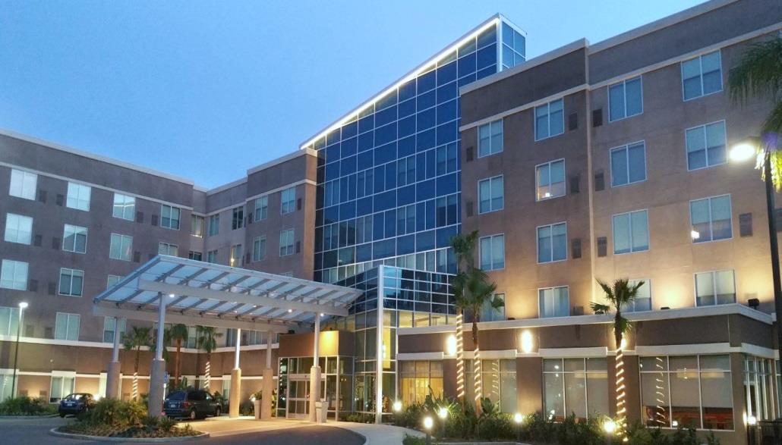

Combines style and innovation to create a completely new hotel experience. An experience that offers an array of services and features designed to meet the evolving needs of today’s travelers for leisure or convention events.

HOTEL FEATURES & SERVICES

♦ Complimentary Wi-Fi
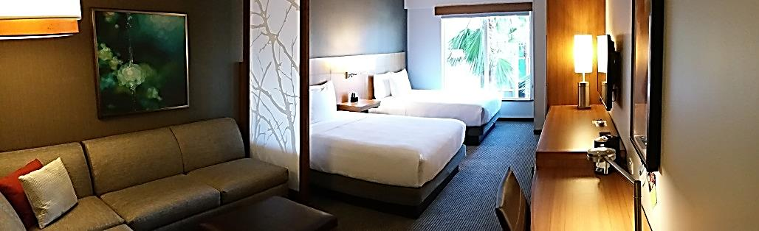
♦ Gallery Hosts available 24/7
♦ 24/7 e-Room with complimentary public computers and remote printing
♦ 24 Hour Stay Fit® Hyatt Fitness Center
♦ 100% Non-Smoking Hotel
♦ Outdoor Heated Pool and Spa
♦ Meeting Space Available
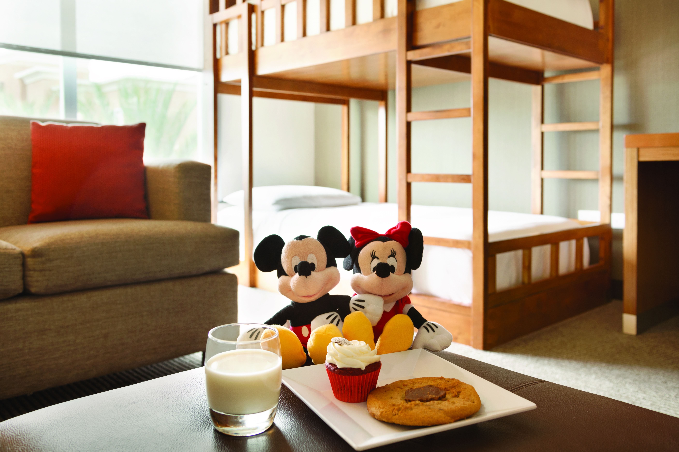
♦ Conference Room for Groups, Family Reunions and Business Meetings
Specialty Rooms with Bunk Bed, King Bed and Cozy Corner Sofa Sleeper – great for families
♦ Tour and Ticket Desk
♦ Disneyland® Resort Park Hopper® Tickets
♦ ADA Accessible
♦ Walking Distance to the Disneyland® Resort and ART Shuttle Service as option

ROOM FEATURES

♦ Hyatt Grand Bed®
♦ 42” Flat-Panel HDTV
♦ Oversized Cozy Corner sectional Sofa-Sleeper
♦ Refrigerator and Single Serve Coffee Maker
♦ Separate Workspace
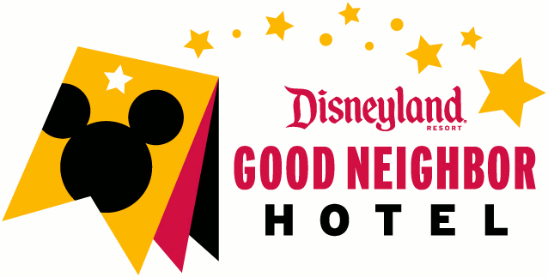
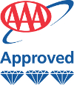

As to Disney's photos, logos, properties: ©Disney/Pixar
“All features of tickets, offers and events, and age range, services, attractions and entertainment may be seasonal and are subject to change without

2035 S Harbor Blvd 714-750-4000 Anaheim CA 92802 anaheimresort.place.hyatt.com

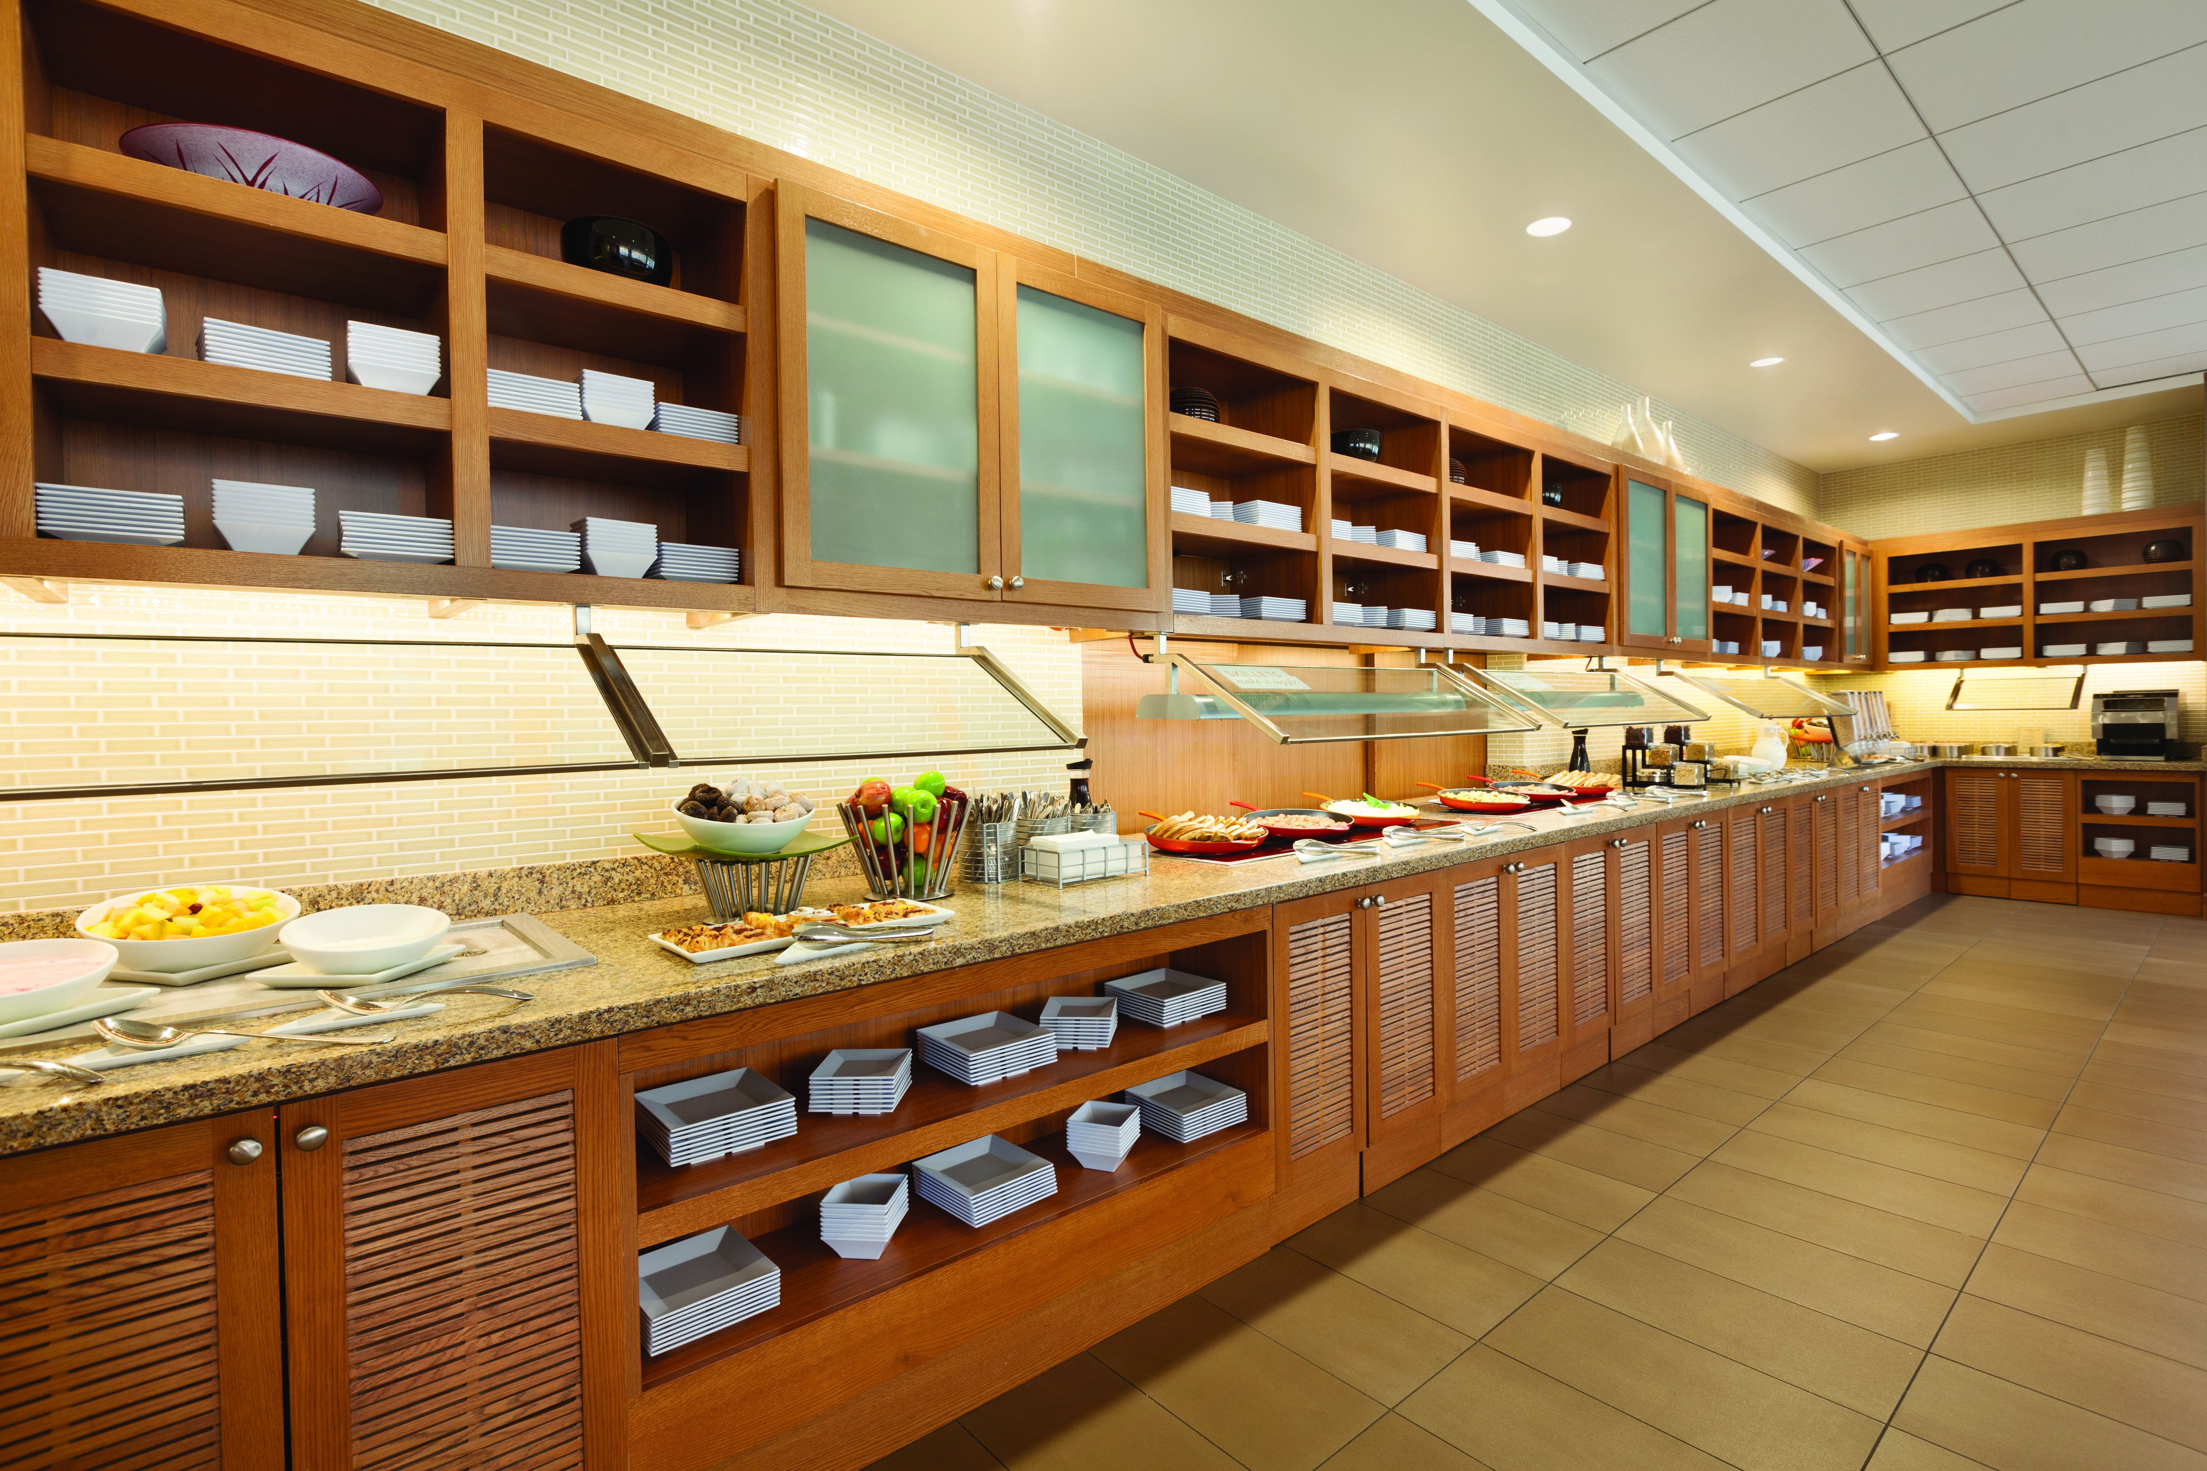
DINING OPTIONS

♦ Coffee to Cocktails bar offering Starbucks® specialty coffees, freshly baked pastries, premium beer, wine and cocktails

♦ 24/7 Gallery Market offers a selection of bottled beverages and snacks and prepared to order options from our Gallery Menu

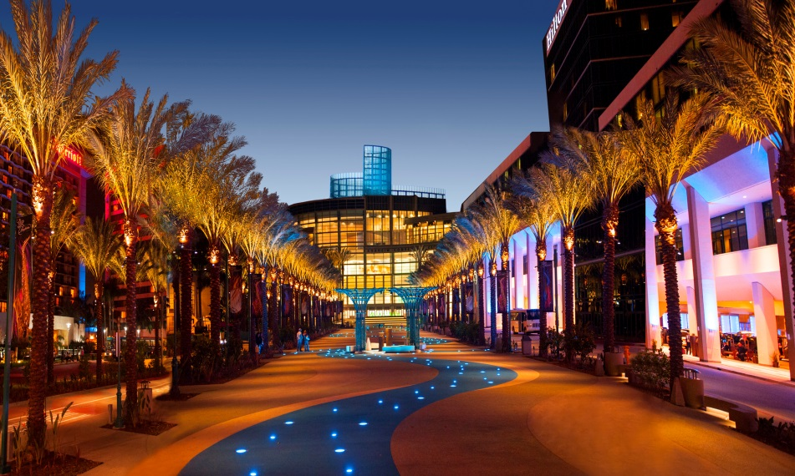
Conveniently adjacent to the
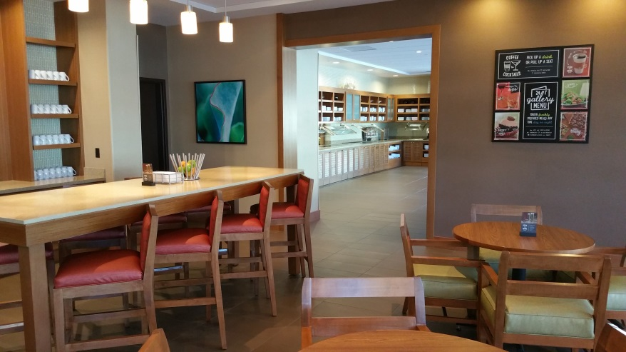
Anaheim Convention Center

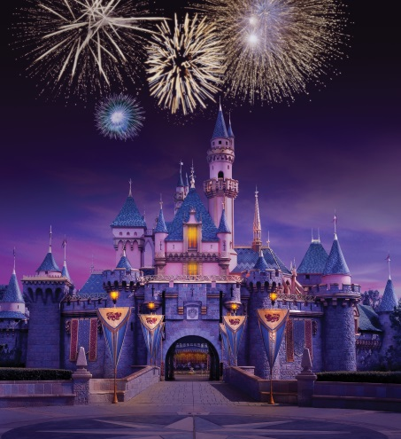
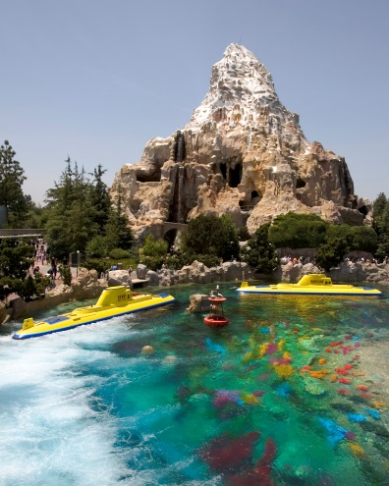
LOCAL ATTRACTIONS
♦ Disneyland® Park
♦ Disney California Adventure® Park
♦ Downtown Disney® District
♦ Anaheim Convention Center
♦ The Shops at Garden Walk
♦ The Outlets at Orange
♦ Angel Stadium
♦ Honda Center
♦ Knott’s Berry Farm
♦ Universal Studios Hollywood
♦ Sea World San Diego

2035 S Harbor Blvd 714-750-4000 Anaheim CA 92802 anaheimresort.place.hyatt.com

