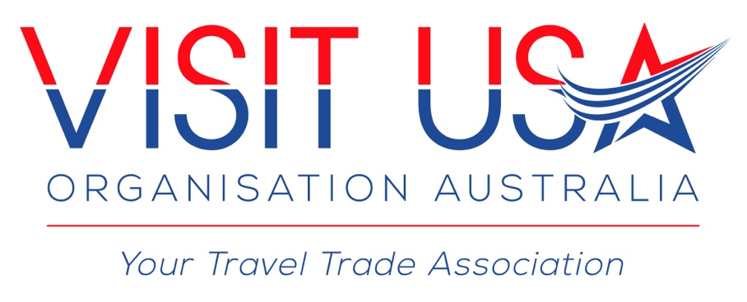

CONFLICT OF INTEREST POLICY
DATED: 01 OCTOBER 2016

Preamble
Integrity is a core value of any organisation, and the Visit USA Organisation (Australia) (Organisation) is committed to providing a fair and ethical environment for the conduct of its operations both locally and overseas.
This Conflict of Interest Policy (Policy) outlines the expected standards of behaviour in relation to actual, potential or perceived conflicts of interest which may arise from personal interests and benefits to ensure, insofar as reasonably practicable, impartial and transparent decision making when interacting with members, suppliers and other key stakeholders.
Mandatory requirements
All individuals covered by this Policy must perform their duties in a fair and unbiased way, and not make decisions which may be perceived as advancing self interest or personal gain.
Conflicts of interest must be disclosed, and reasonable steps should be taken to avoid these in connection with an individual’s duties and obligations in relation to the Organisation.

i) Conflicts of interest
A conflict of interest is a situation where an individual covered by this Policy could be influenced, or be seen to be influenced, by a personal interest in carrying out their official duties. A conflict of interest can arise from avoiding losses or gaining advantage for self or others (whether financial or otherwise) and can be actual, potential or perceived.
An actual conflict of interest involves a conflict between an individual’s duties and responsibilities in serving the Organisation’s best interest, and the individual’s existing private interests.
A potential conflict of interest arises where an individual has private interests that could conflict with their official duties in the future.
A perceived conflict of interest exists where it appears, or where it is or could be perceived, that an individual’s private interests could improperly influence the performance of their official duties, whether or not this is in fact the case.
To facilitate transparent and ethical decision making, all individuals covered by this Policy must avoid any actual, perceived or potential conflicts of interest.
If an actual, perceived or potential conflict arises, individuals must report the conflict of interest in writing to the Secretariat of the Organisation when the conflict is identified. Individuals will receive written acknowledgement that their conflict of interest has been received. The conflict of interest must then be registered in the agencies’ Conflicts of Interest Register.
Conflicts of interests can involve pecuniary interests (financial interests or other material benefits or costs,), or non-pecuniary interests (such as personal or family relationships). They can involve the interests of the individual or their immediate family or relatives, friends, business partners or associates (where these interests are known by the individual). They include any tendency toward favour or prejudice resulting from friendship, animosity, or other personal involvement with another person or group.

ii) Examples of conflicts of interest
The following are examples of conflicts of interest. This list is a guide to assist individuals when considering if situations could be a conflict of interest, and is not exhaustive:
a) an individual on a selection panel is a friend, relative or foe of an applicant for a position;
b) an individual assessing RFPs from companies in which they, relatives, friends or foes have an interest;
c) an individual, or a related party is the director/shareholder of a company that may be affected by policy changes being considered;
d) an individual, or a related party is the beneficiary of a prize or benefit provided to the Organisation for the benefit of trade show attendees
To assess if there may be a conflict of interest, individuals may find it useful to consider, either by themselves or in consultation with their manager, the following five points:
1. Is the decision or conduct ethical?
2. Do these outcomes raise a conflict of interest or lead to private gain?
3. Can the decision or conduct be justified in terms of the Member interests and would it withstand public scrutiny?

iii) Gifts, Prizes and Benefits
A gift is an item of value which one person or organisation presents to another (for example, this may include but is not limited to such things as gift vouchers, entertainment, hospitality, travel, commodity, property etc).
A benefit is a non-tangible item of value (for example, this may include but is not limited to such things as a new job or a promotion, preferential treatment or access to confidential information) that one
A gift is an item of value which one person or organisation presents to another (for example, this may include but is not limited to such things as gift vouchers, entertainment, hospitality, travel, commodity, property etc).
A benefit is a non-tangible item of value (for example, this may include but is not limited to such things as a new job or a promotion, preferential treatment or access to confidential information) that one person or organisation confers on another.
Acceptance of a gift, prize or benefit can create a sense of obligation that may compromise impartial and honest decision making, and may be perceived as a bribe to further personal or business interests. In the business context, gifts and benefits can have different meanings and purposes. The purpose of the gift or benefit, to a certain extent, affects how it should be managed.

a) Examples of gifts or benefits
Gifts and/or benefits related to official duties or personal relationships may include, but are not limited to
- offers of cash, gift vouchers/cards, shares or other monetary equivalents; gifts, such as bottles of wine and/or manufacturers’ samples;
- promotional materials, including clothing, books, CDs or DVDs; provision of goods or services for personal use, such as labour or building materials;
- gifts to family members that arise in connection with the individual’s member’s official duties;
- prizes obtained during work related functions being organised by a third party;
- prizes, gifts and/or benefits that are won as a result of entering a competition while engaging in official duties, e.g. lucky door prizes at trade shows, supplier run competitions

b) Managing Gifts, Prizes and Benefits
The Executive and Committee Members of the Organisation must not accept gifts, prizes or benefits in any circumstance.
The Organisation has set monetary amount $100 under which gifts and benefits can be accepted if it does not compromise the individual, the agency or cause an actual, potential or perceived conflict of interest.
Given the nature of the Organisation however, it is to be noted that there are benefits in relation to accommodation and flights that may be offered to the Executive Committee in situations such as attendance at International Pow Wow. These potential benefits will be dealt with on an individual basis as soon as the Executive Committee is advised of the situation.

iv) Breaches of this policy
The Executive Committee may commence disciplinary action, once notified by the Secretariat, if a person to whom this Policy applies, breaches this Policy (or any of its related procedures), up to and including being asked to step down from the Executive Committee position which they hold and from Memberships of the Full Committee.
Breaches of this Policy or non-disclosure may be reported to the Independent Commission Against Corruption (ICAC) or, if they involve criminal activity, to the NSW Police Force.

Approved by the Executive Committee of the Visit USA Organisation (Australia)

Dated: 01 October 2016

