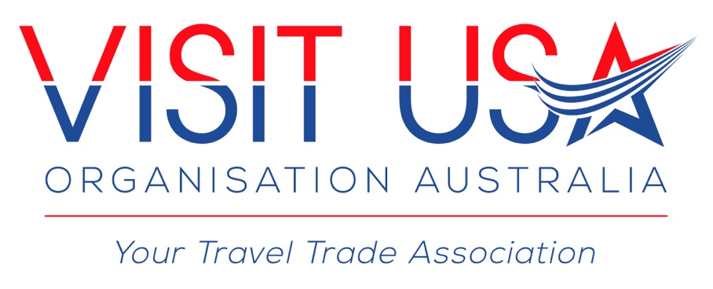

COMMUNICATIONS POLICY
DATED: 01 MARCH 2016

1. Purpose and Scope
The Visit USA Organisation (Australia) (VUSA / Organisation), a Not For Profit Organisation, is committed to effective dissemination and receipt of information and communication within the organisation and to its members, stakeholders and the media.
The purpose of this policy is to provide guidance to VUSA in developing and implementing communication strategies. This policy applies to all Board members, Committee members, Honorary Committee Members, Contractors, volunteers and students alike and encompasses:
- Purpose of Communication
- Communication Tools and Mechanisms
- Liaison with the Media

2. Principles
Communication systems and equipment will be used only for the purpose of achieving the Organisations’s objectives.
Clear, consistent and equitable communication within and outside the Organisation is essential for effective operations.
External communication with the Organisations, stakeholders and media must align with the Organisation’s strategic objectives.

3. Outcomes
Members and Stakeholders are informed of, and consulted on, activities and operations.
External communication increases awareness and understanding of issue relevant to VUSA, its members and the North American travel sector.
Internal communication supports good knowledge management and operations within the organisation.
4. Internal Communications
Internal communication should be guided by regularly scheduled and attended Member Committee meetings, regularly printed and / or emailed information updates as well as a forum for suggestions.
A Not For Profit should also encourage internal communication that welcomes alternative perspectives, invites and encourages participation at all levels, minimises defensiveness and builds and maintains camaraderie. The Board should solicit actively, listen carefully and respond respectfully to the views of its Committee Members.

5. External Communications
External communications should be guided by clear marketing and public relations efforts, in conjunction with the Organisation’s Public Relations Officer. These may include a newsletter, website update, Annual Report, promotional brochures and flyers, news releases, press conferences and feature stories.
A Not for Profit) must identify its Spokesperson, in the case of the Visit USA Organisation (Australia) it is the President and in their absence the Vice President or the Public Relations Officer, where authorised, who can address the Media. In relation to contacting and disseminating information to the Members of the Organisation / Stakeholders or other interested parties, this lies with the Executive Board as a whole and each and any of the following, only, may address the Organisation’s members:
President
Vice President
Secretariat
Secretary
Treasurer
Public Relations Officer
No other Committee Member or Honorary Member may distribute information to the Organisation’s Members other than those outlined above, without prior written approval.
Members of Visit USA Organisation (Australia) should be provided with appropriate, ongoing opportunities to interact with the Board and Member Committee regarding the Organisation’s activities.
The Organisation will promptly and respectfully respond to grievances or complaints from its Members.

6. Branding and Corporate Image
All outgoing communications must carry the Visit USA Organisation (Australia)’s name and / or logo, including letters, reports, project materials, emails and policy submissions.

